Nama : Aditia Surya Putra

Kelas : Flutter D

Source Code:

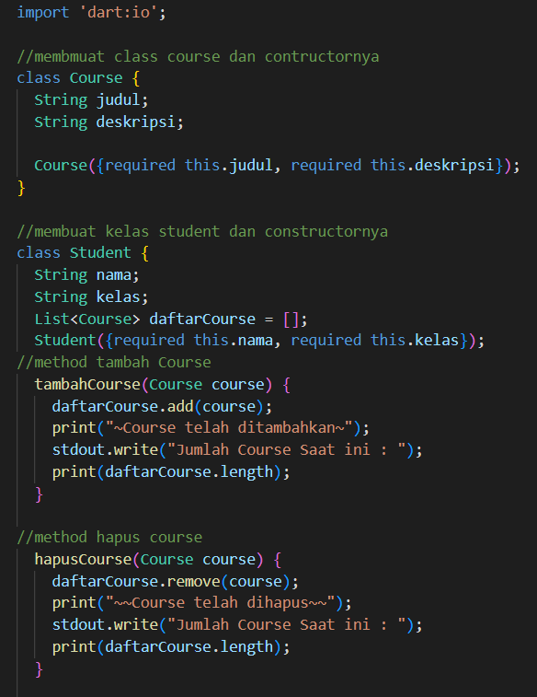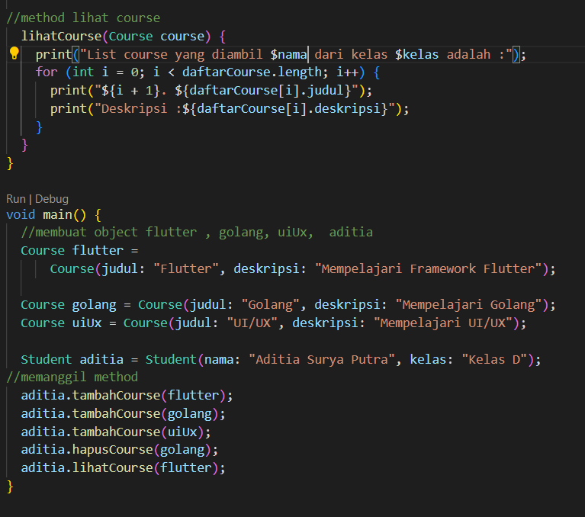

Output

TambahCourse

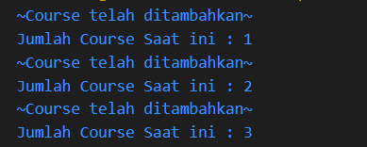

hapusCourse



lihatCourse =

